**Price Waterfall in CPQ:**

* The pricing Salesforce CPQ determines how it calculates the Net Price after applying various rules and discounts to a starting list price.
* The predefined prices in each category, like the original price and list price, are standard features included in CPQ. This approach follows a top-down method known as the **Price Wate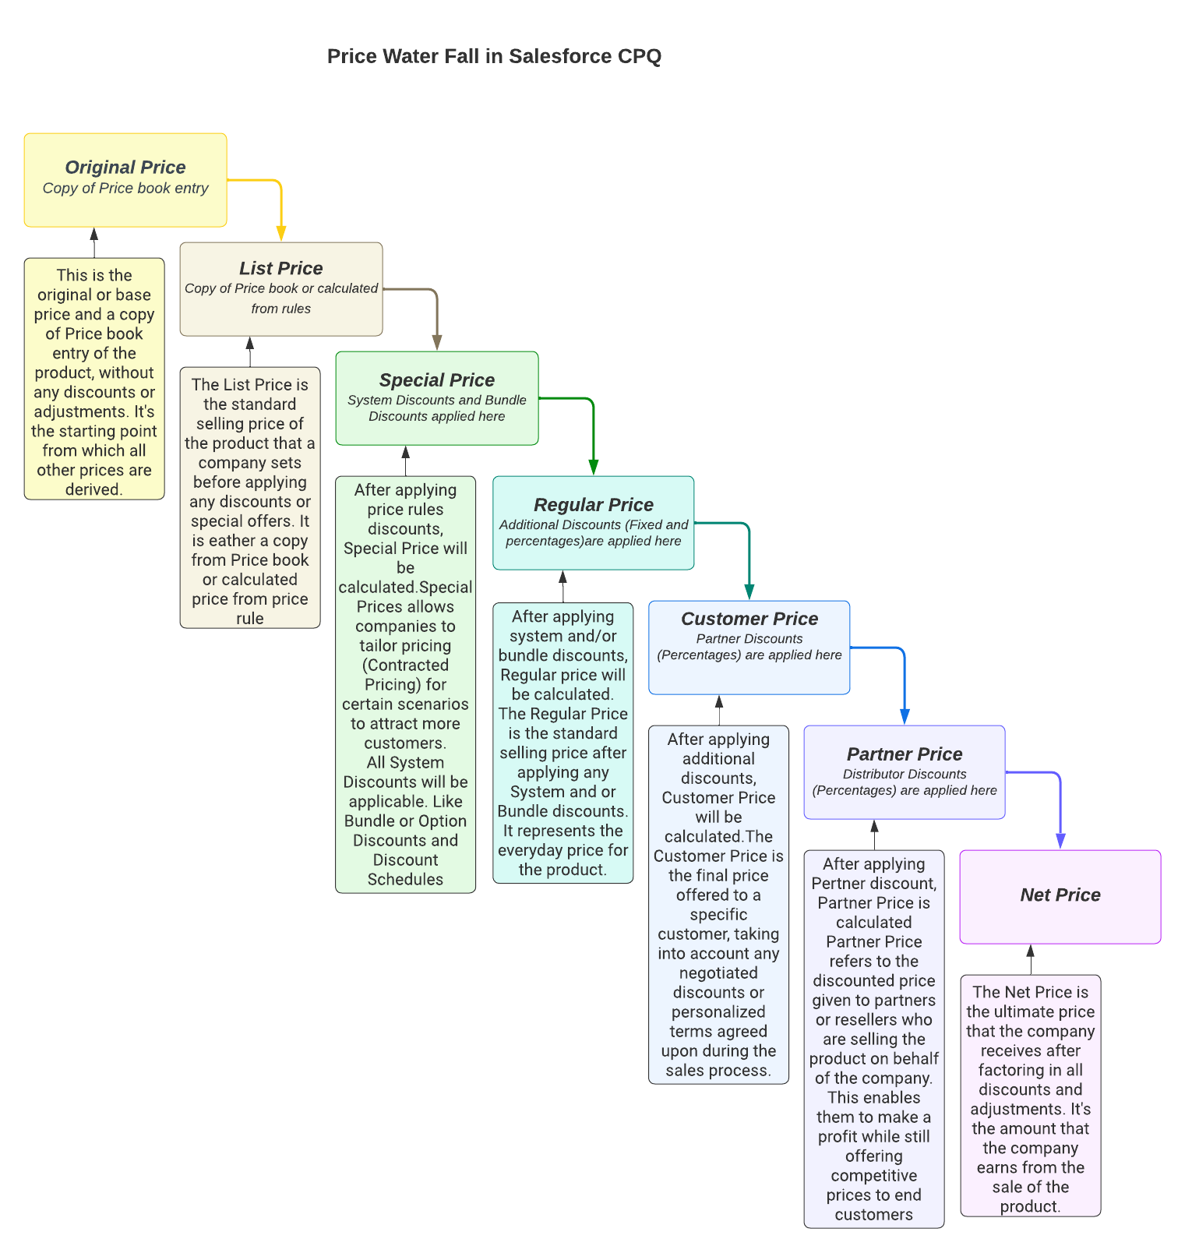rfall**, which helps in calculating the overall prices.
* The below image describes each of 7 Prices Structure in Salesforce CPQ.

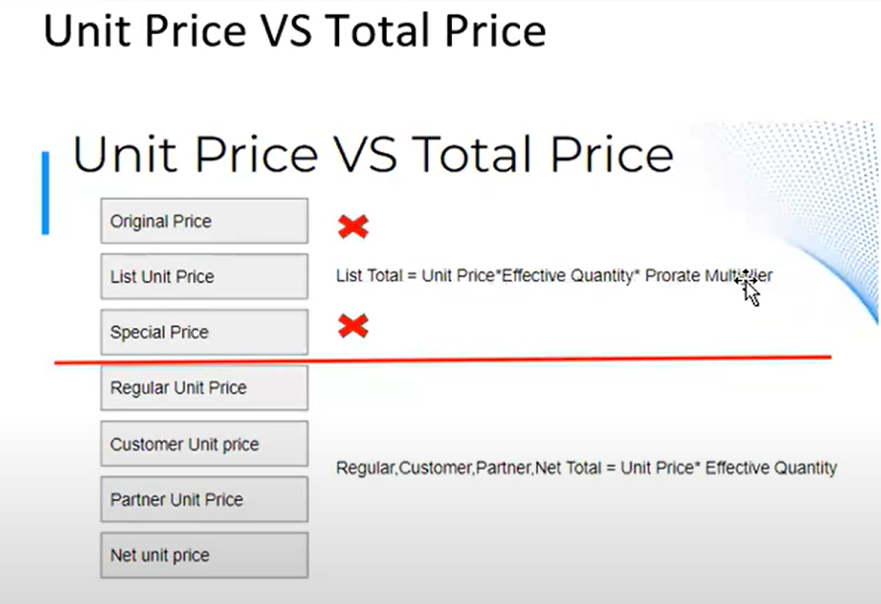

**Effective Quantity**:

Effective quantity field represents the actual quantity that Salesforce uses while calculating prices for that quote line. For some objects, such as amended quote lines and quote lines from slab-discounted or block-priced products, the effective quantity has a different value than the quantity.

**Amended Quote Lines**: Amendment quote lines have an effective quantity that represents the difference between the original quote line's quantity and the amended quantity. For example, if your original quote line had a quantity of 10, and your amended quote line had a quantity of 15, the amended line would have an effective quantity of 5.

**Block-Priced Quote Lines**: Block prices are not unit prices, so Salesforce CPQ doesn't multiply a block-priced quote line's quantity by its price. Instead, Salesforce CPQ uses quote

**Slab-Discounted Quote lines**: Salesforce CPQ uses the quantity entered for slab products only for the calculation of the discount percentage applied to each unit. Because the per-unit discount percentage can vary across units depending on the tier, the quote line does not have a consistent per-unit price. All slab-discounted quote lines also have an effective quantity of 1 for all other pricing calculations on the quote line.

**Override the Price water fall with the help of Special Fields -**

**AdditionalDiscountUnit:** Changes how additional discount is calculated, Providing more options than percent of flat amount (% Amount Unit Override Total Override)

**ApplyAdditionalDiscountLast:** Applies additional discount to net price, after all other discounts

**ApplyPartnerDiscountFirst:** Moves the partner discount and partner price to before system discount and regular price

**ChannelDiscountsOffList:** This will calculate the values of partner and distributor discounts, expressed as percentage, off of the list price rather than the discounted price

**ProrateAmountDiscounts :**This will multiply a flat amount discount in the additional field by the prorate multiplier.

Interview Questions:

1. **Price rules** will affect on which type of price field at quote line? – **List Unit Price**
2. **Contracted Price** will affect on which type of price field at quote line? – **Special Price**
3. **Discount Schedule** will affect on which type of price field at quote line? – **Regular Unit Price**
4. **Customer Price** ( Applying discount at QLE using Additional Discount Field) will affect on which type of price field at quote line? - Customer Unit Price
5. **Partner Price** will affect on which type of price field at quote line? **- Partner Total**
6. **Distributed Discount** will affect on which type of price field at quote line? – **Net Unit Price**
7. What are the different types of pricing adjustments that can be configured in Salesforce CPQ's Price Waterfall?
8. Can we override the native behaviour of Price water fall?